Annexe 2: Specifications Paper weight

LOT 2 – Paperweight

Model 1: Paperweight representing the OLAF logo with stand: a transparent crystal block measuring maximum 10 x 7cm. The OLAF logo should have a sandblasted look. On stand of the paperweight, the OLAF logo and full name of the Office in English sandblasted (1-color white). Each paperweight will be delivered in a quality dark blue box bearing the OLAF logo in mat silver colour.

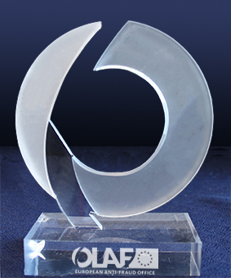

Model 2: Paperweight representing the OLAF logo without stand: a transparent crystal block measuring maximum 9 x 8,5 cm

Engravings:
— the “O” of the acronym OLAF sandblasted imbedded in the crystal at 1/3 of the thickness of the crystal
— the OLAF logo and the full name of the Office in white imbedded in the crystal in between the "O" and the surface of the paperweight.
Each paperweight will be delivered in a quality dark blue housing bearing the OLAF logo in colour.
